C:\Program Files\Microsoft Office\MEDIA\CAGCAT10\j0305257.wmf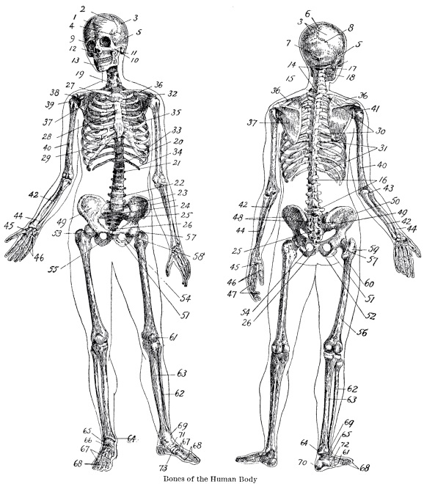**Dear Physiologists and Parents/Guardians,**   
  
Welcome to Honors Human Anatomy and Physiology (HAP)!! This class will be exciting, thought-provoking, and will challenge you to think scientifically to understand life on Earth.  
  
I am incredibly excited to have each of you in my class. I am counting on each of you to bring perseverance and a willingness to learn as we embark on our biology journey this semester. This class has a TON of interesting and relevant content to our health and daily lives. Are you interested in how organs and tissues in your body function together to support life? Are you interested in learning more about topics that relate to the medical/health fields? Are you ready to be challenged in an upper level science class? This is the class for you!  
  
Armed with one of the most exciting subjects in science (my own bias), we will focus on problem-solving skills, critical thinking, applying the scientific method, and the application of anatomy and physiology to public health, global awareness of healthcare issues, as well as to the many jobs and careers related to the fields of anatomy and physiology.  
**Materials:**  
  
·         A 3-ring binder (you may share with other classes)  
·         Loose leaf paper  
·         Pencils and pens (blue or black ink) and colored pencils

**Class Materials Wish-List**  
  
This list is our class wish-list. These are items we are in need of in the classroom, and I would be so grateful for parent help in providing these items for our biology students! You may also wish to carry some of these items with you.   
  
·         Glue sticks (**very** needed!)  
·         Hand Soap (many labs!)  
·         Tissues!  
·         Lysol disinfectant wipes  
  
**Classroom Procedures**  
  
Students require a safe and inviting place to learn. I will always provide this for my students, and I need help from each student to ensure that our biology classroom is a conducive place to learn.  
  
1.       **Always be prepared.** This means students are expected to be prompt to class, must have the required materials, and must be ready to learn when the bell rings (in a seat and attentive).  
  
2.       **Do your best.** This is all that I can ask from any student and budding biologist. As long as you are doing all that you can to succeed, and you are seeking help to improve, you are doing an excellent job in my book.   
  
3.       **Please do not bring any food or cell phones out of your bag in my classroom.** Phones should not be used in class unless otherwise directed (for research or review) by the teacher, and should not be turned on silent.  Food can be dangerous in a science laboratory, and will not be eaten unless it is part of a lab. Drinks are allowed as long as they have a top and are not out during a lab.  
  
4.       **Respect yourself, respect your classmates, and your teachers.** I promise to always provide an atmosphere of respect and understanding for everyone. This classroom is a HATE FREE ZONE.   
**Students will be expected to adhere to all Riverside High School rules while in our science classroom.**  
  
**Textbook**  
  
The textbook we will be using for this class is Pearson’s Human Anatomy & Physiology Eighth Edition 2010 (Marieb and Hohn). Students will be issued textbooks. We do not have enough textbooks to maintain a classroom set, thus, students will be required to transfer them to and from class.  
  
**Grades and Progress Reports**  
  
The DPS grading scale as of 2015-2016 is a ten-point scale. Our class grades will follow this scale, where 90-100 is an A, 80-89 is a B, and so on. Following is the breakdown of **percentage weights for Honors HA&P**:

* **Tests and Quizzes 35%**
* **Reading and Lecture Notes 25%**
* **Labs, Projects, and Classwork 30%**
* **Class Participation 10%**

**The Final Exam**

Students will complete and present a final project as their final exam grade. There will be no exemptions.

**Quarter 1 Grade (40%) + Quarter 2 Grade (40%) + Final Exam Grade (20%) = Final Grade**  
Students and Parents/Guardians can check grades on **PowerSchool**. Please ensure that both student and parent/guardian have access to his or her PowerSchool account!

Grades will be updated electronically on a regular basis, and printed progress reports will go home every five weeks.  
**Tutoring**  
A&P tutoring occurs on Tuesdays and Thursdays after school from 4-5 PM. In the past, transportation has been provided through Riverside on these days (transportation to students’ homes on a late bus). If you are interested in this service, I can inform you if this practice will continue as soon as I am notified.  
**Absences**  
It is imperative to be present in class every day in order to be successful. I cannot stress the importance of great attendance enough in a challenging content-driven course such as Honors Anatomy and Physiology. If you must miss class for an excused absence such as an appointment, family emergency, illness, etc., you will be responsible for obtaining your absent work when you return, and you will have 3 school days to turn in work or make up a missed quiz/test before that assignment is considered late. **Late work is not accepted in HAP!**   
  
Students who have an excused absence (note from parent/guardian or physician) **must make up a test within 3 school days of returning from the excused absence**. If the absence is unexcused, the student will have a 24 hour period to make up the missed test.

**Contact: Ms. Holly A. Byers, MAT Email: holly.byers@dpsnc.net**

**Phone: 919-560-3965 ext. 65223 Wesbite: byersscience.weebly.com**

**By signing below, each person is acknowledging that they have read and understand the above information and understand their role.**

**_Holly A. Byers____________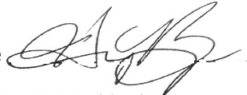 ___8/29/16______**

**Teacher Name Signature Date**

**__________________________________________ ________________**

**Student Name Signature Date**

**__________________________________________ ________________**

**Parent or Guardian Name Signature Date**